**Phase-2:** **Salesforce Org Setup & Configuration:**

**1. Salesforce Editions:**

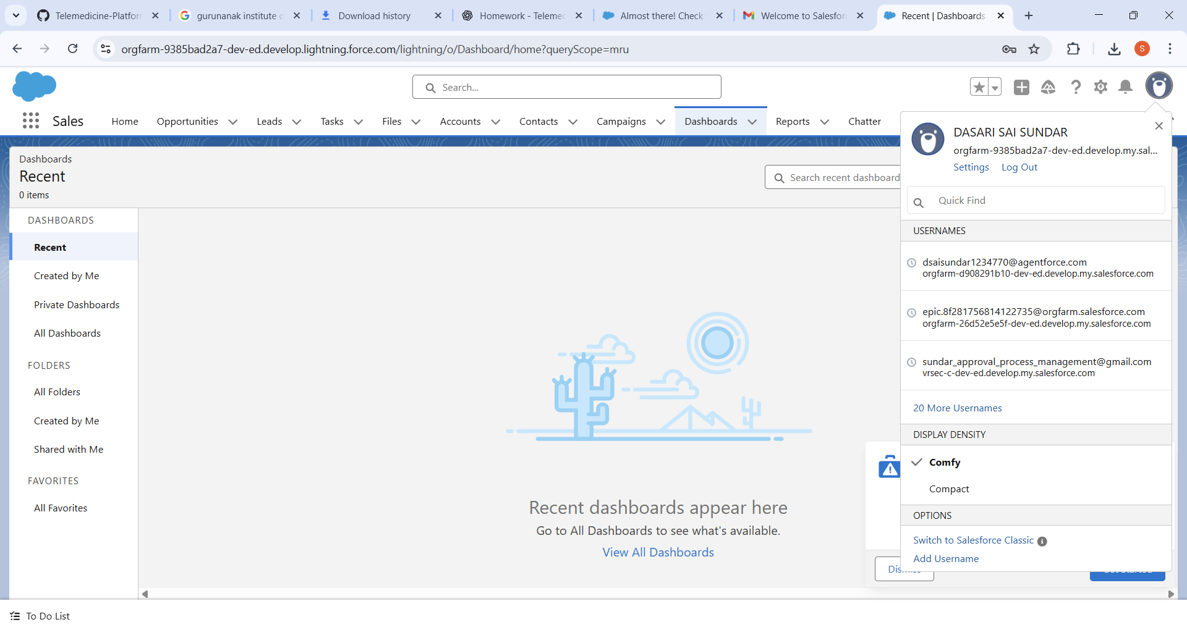

We selected the **Developer Edition Org** for this project. A free developer org was registered from Salesforce, which provided all standard CRM features along with advanced tools like APEX, Lightning Web Components (LWC), APIs, and AppExchange access. This org was chosen because it is free, permanent, and includes all features required for development. The Developer Edition was used as the base environment for the telemedicine system. It was set up with administrator access and configured for customization.

**2. Company Profile Setup:**

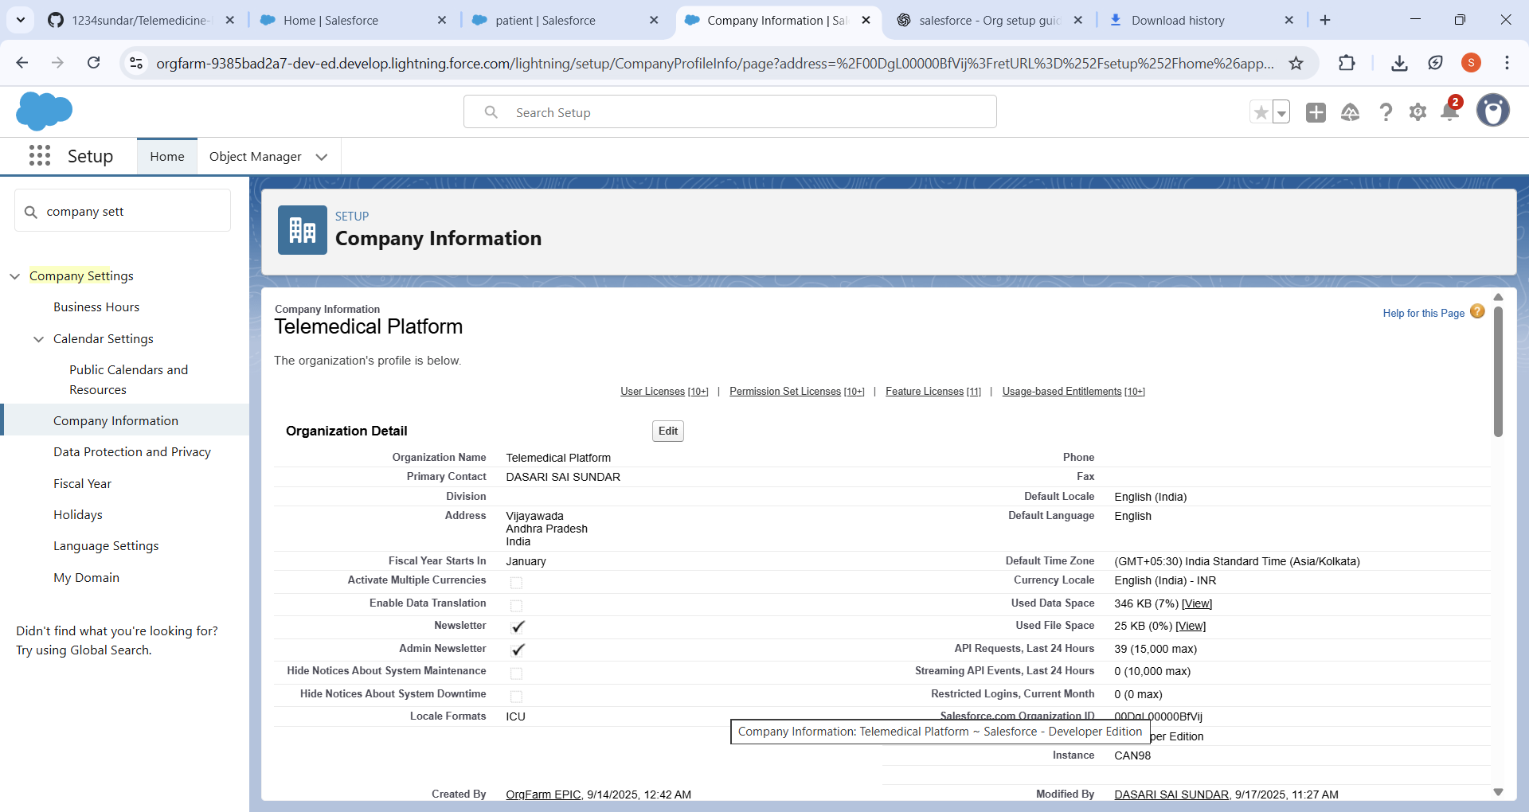

The **Company Profile** was configured under Setup → Company Settings → Company Information. The organization name *TeleMedCare Pvt Ltd* was added along with the registered address. The local time zone was set to **IST (India Standard Time)** to align with working hours. The default currency was set to **INR**, and the default language was set to **English**. This ensured that appointment schedules, billing, and reporting were accurate for the region. All settings were saved and verified.

**3. Business Hours & Holidays:**

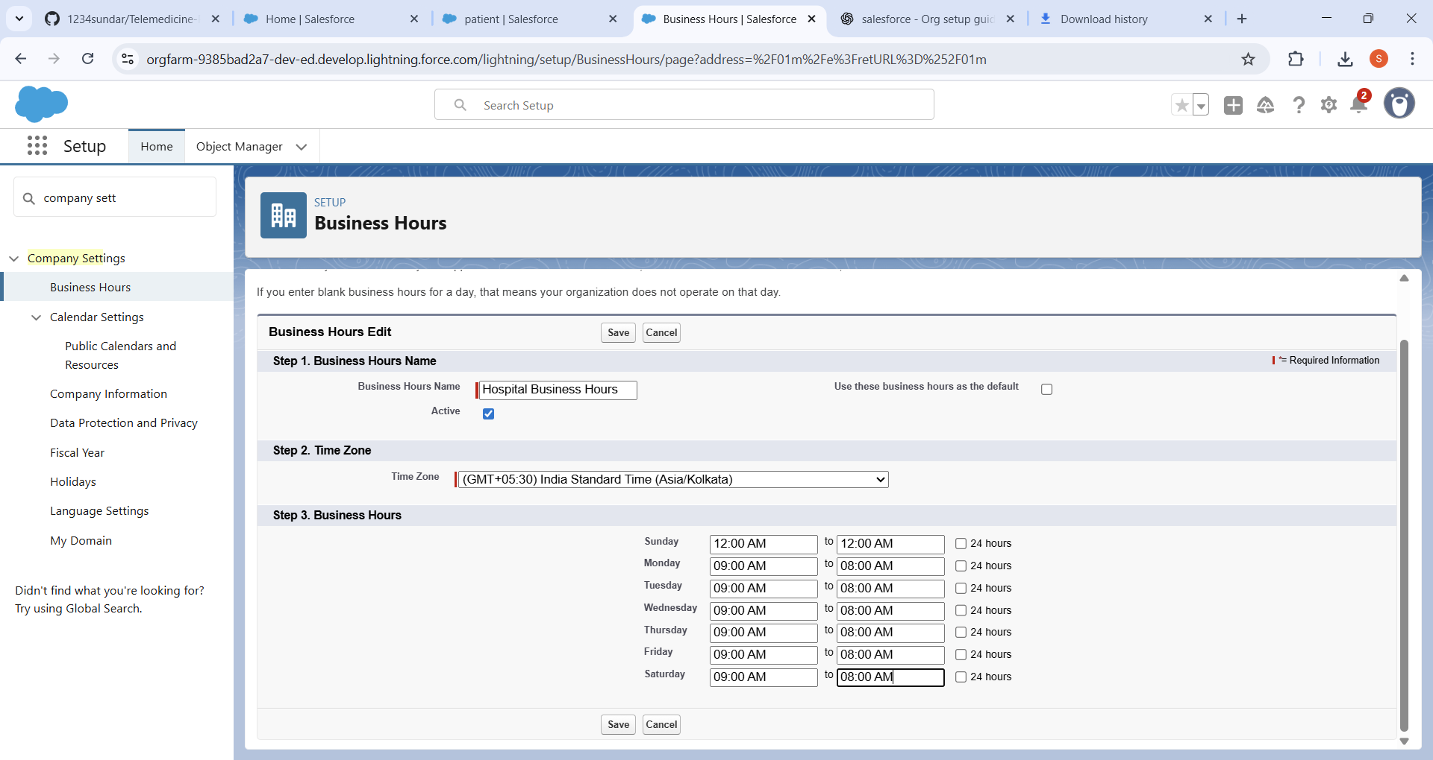

The **Business Hours** were created for doctors with working timings of **9 AM – 8 PM, Monday to Saturday**. Sundays were left as non-working days. Public holidays were also added to the system, preventing patients from booking appointments on those days. These business hours were linked to the service setup, ensuring that appointments and prescriptions could only be managed during defined working times. This step ensured realistic scheduling aligned with doctor availability.

**4. Fiscal Year Settings:**

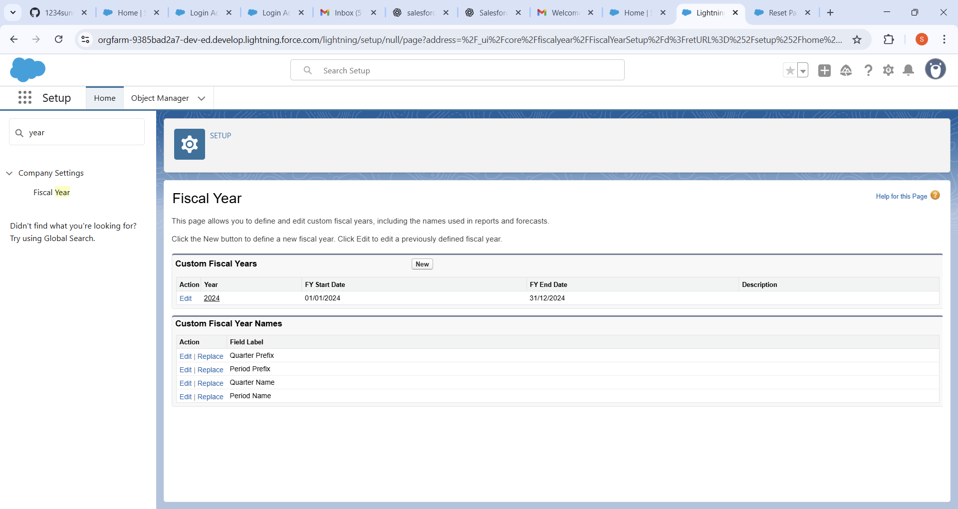

The **Standard Fiscal Year (January – December)** was enabled. A custom fiscal year was not required for this project since healthcare reporting could be handled using the standard model. This configuration ensured that all revenue, appointment, and patient tracking reports aligned with the calendar year. The default Salesforce fiscal settings were left unchanged as they suited the project’s needs.

**5. User Setup & Licenses:**

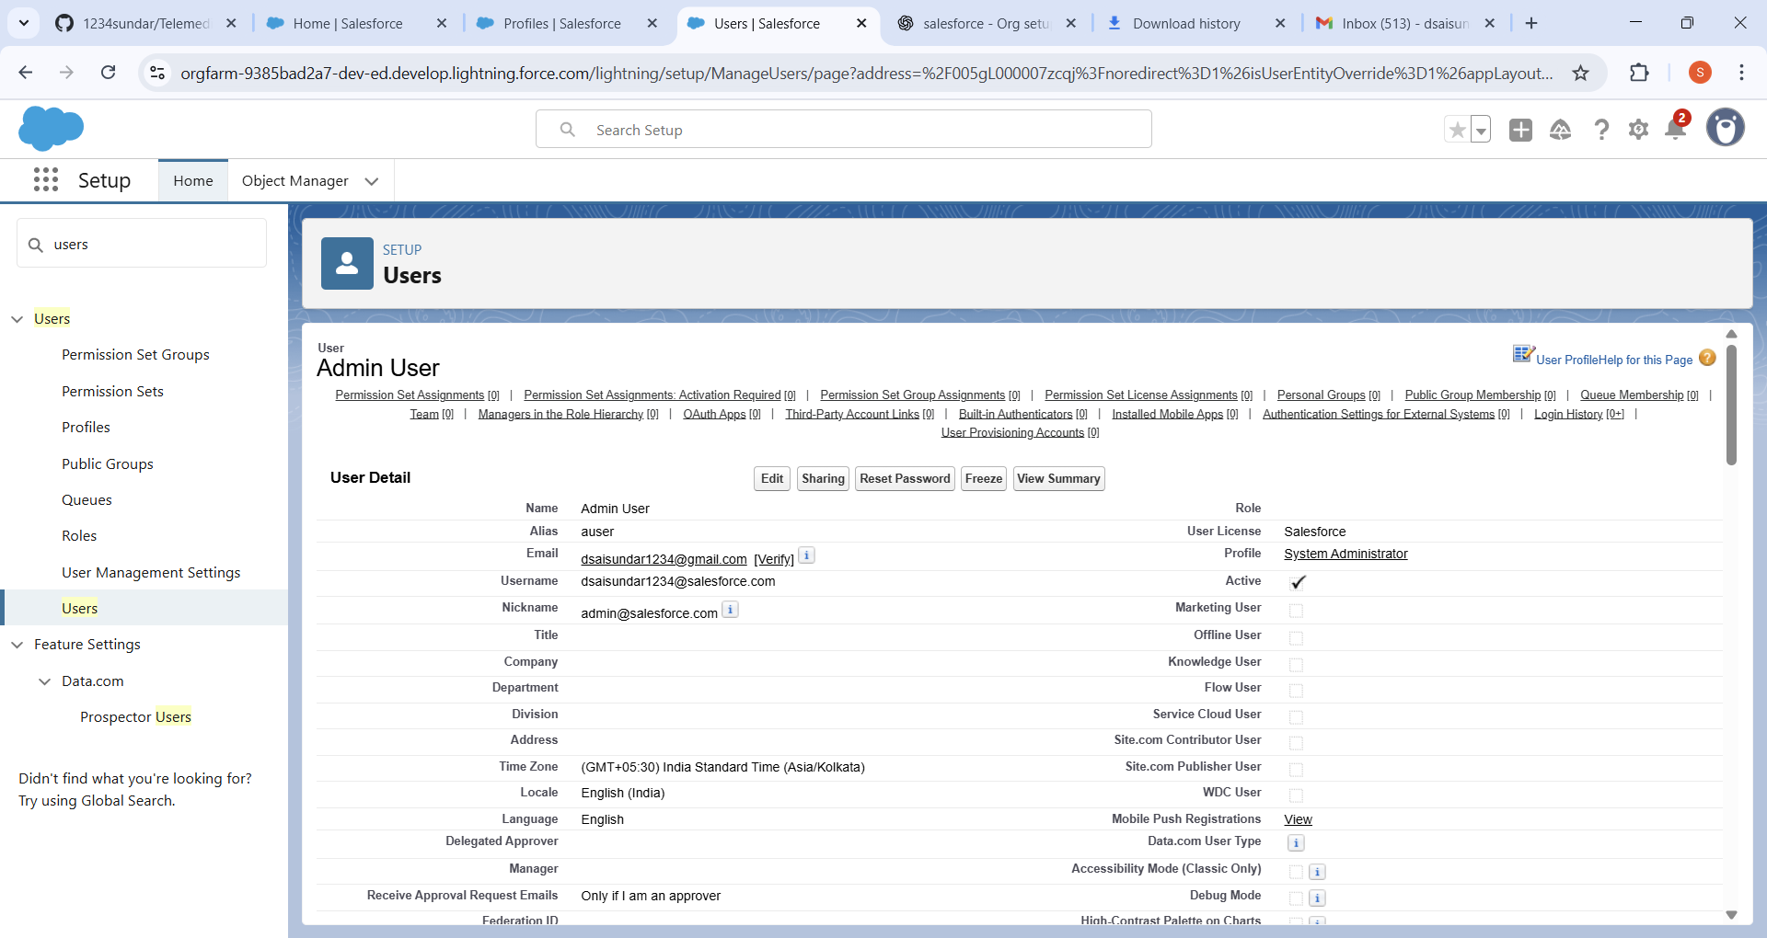

Multiple users were created in the org. An **Admin User** was added with the System Administrator license.

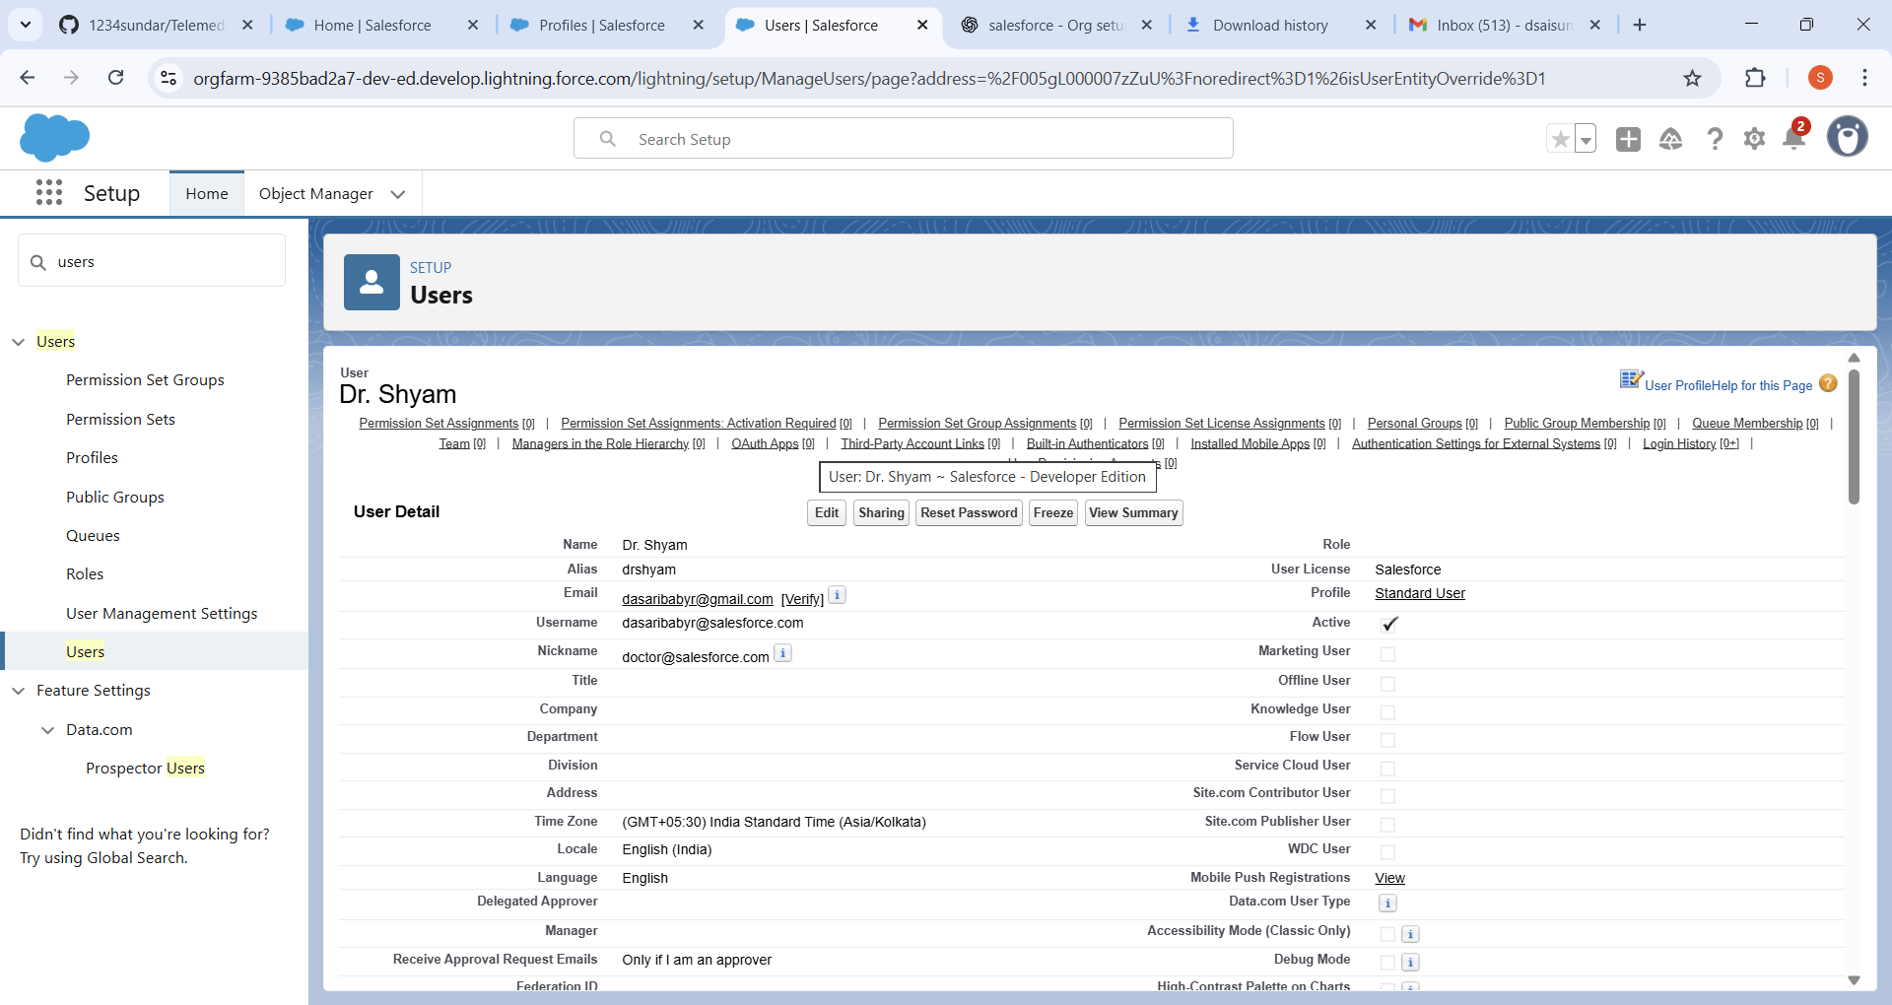

**Doctor Users** were created with Salesforce licenses and assigned to the doctor profile.

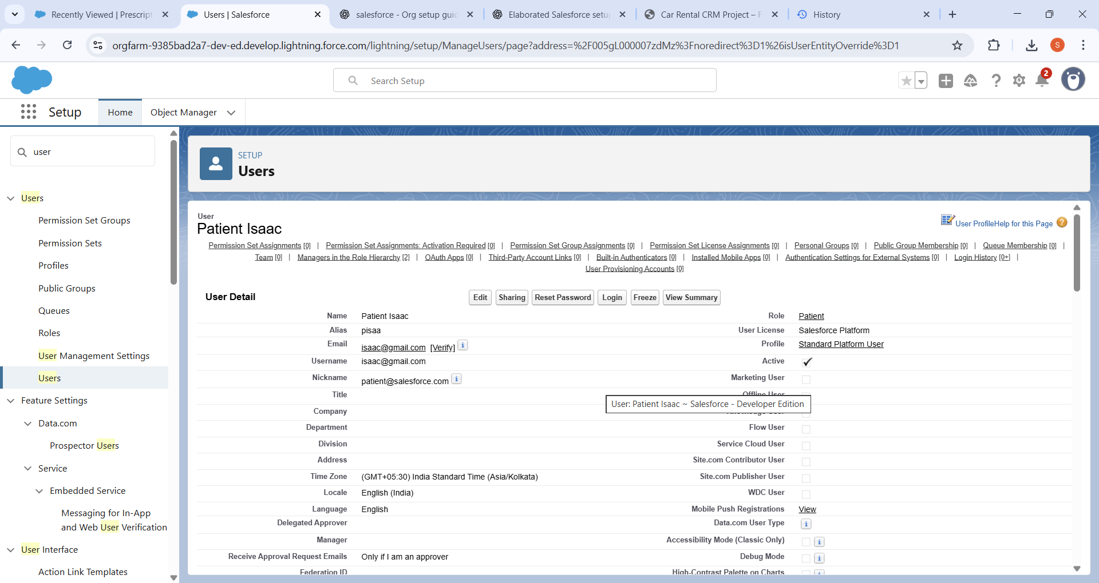

**Patient Users** were also created with Salesforce licenses but given restricted access. Each user was assigned an appropriate role and profile during creation. Email verification was completed for all users, and login access was tested.

**6. Profiles:**

Three major profiles were configured. The **Admin Profile** retained full system access and configuration rights.

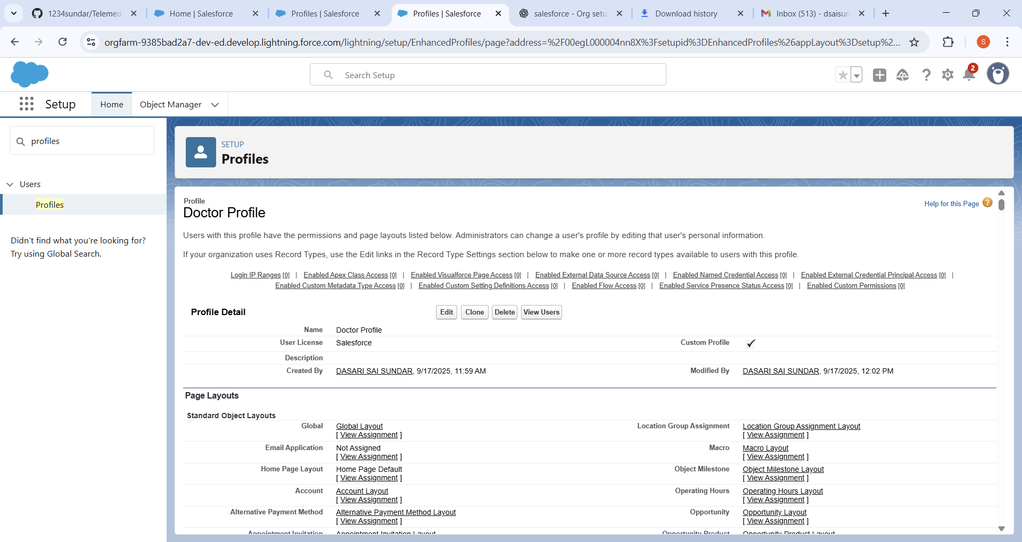

A custom **Doctor Profile** was created to allow doctors to access and update patient records, manage appointments, and create prescriptions.

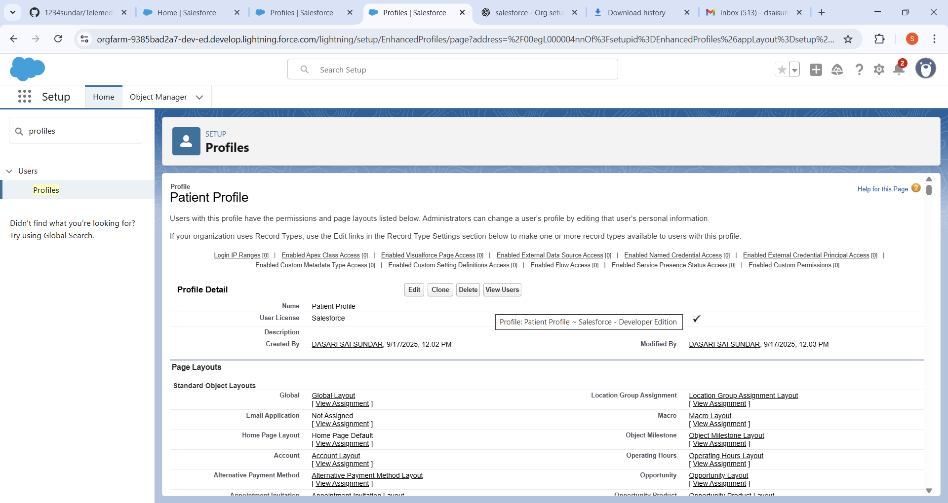

A **Patient Profile** was created with restricted access so that patients could only view their own records and bookings. Each user was assigned the correct profile during setup. This step enforced proper security controls across different roles in the system.

**7. Roles:**

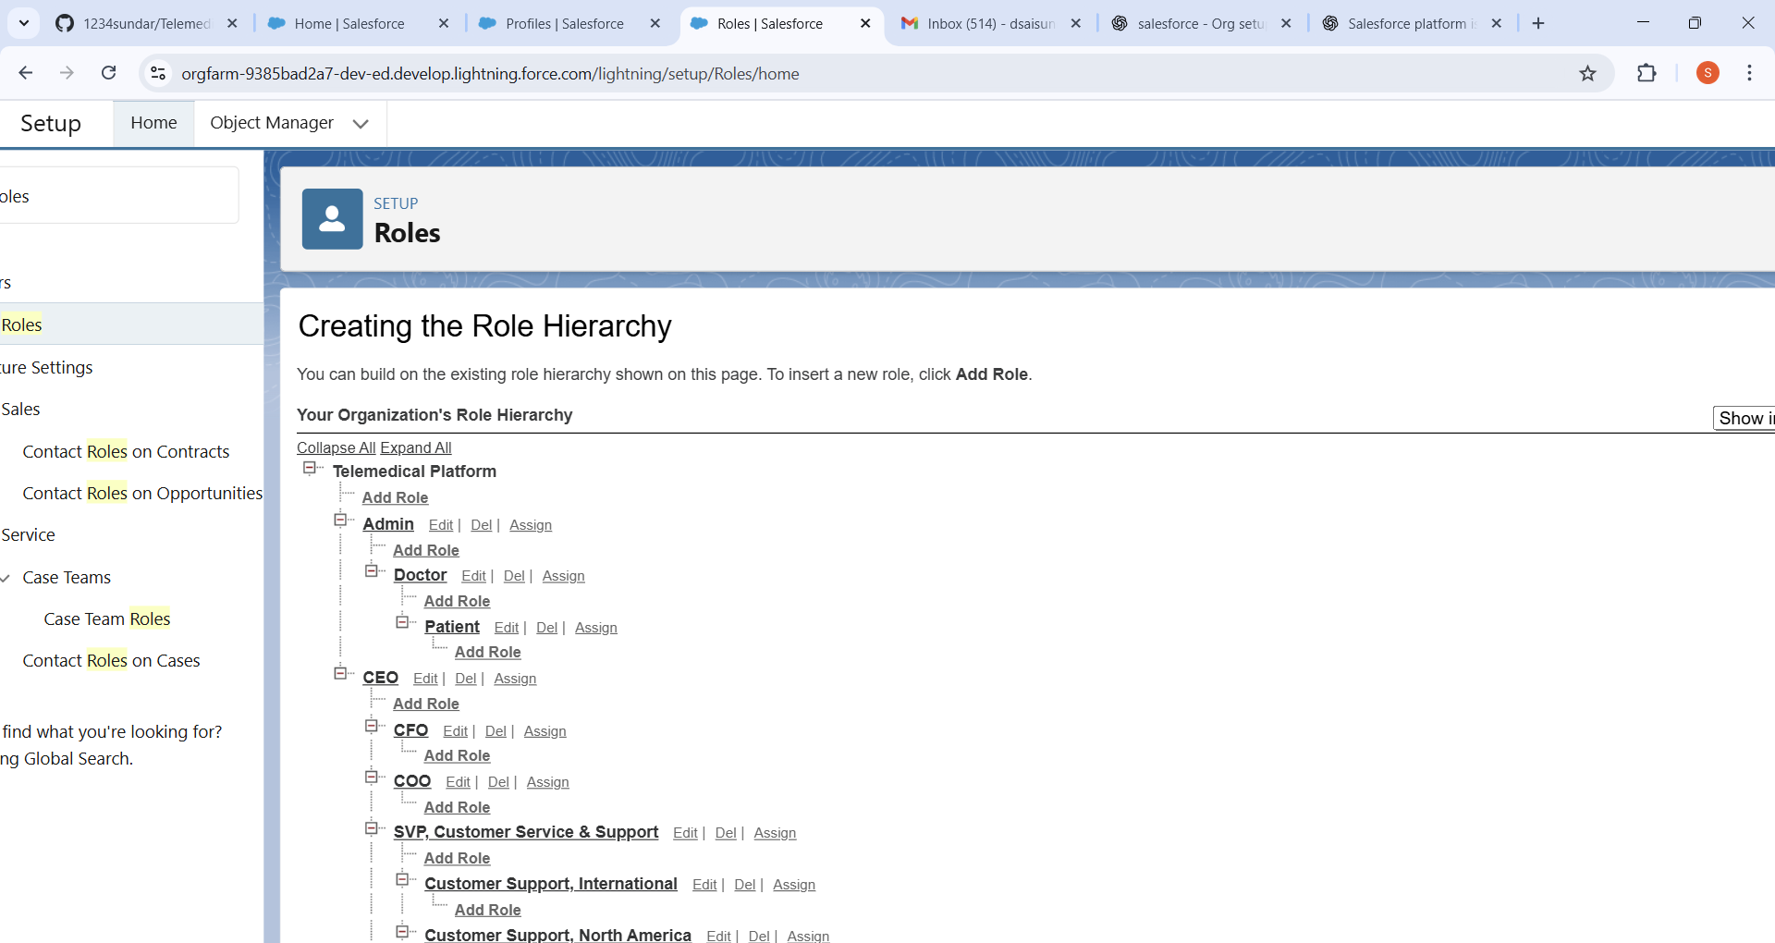

A role hierarchy was created. At the top of the hierarchy, the **Admin Role** was assigned, followed by the **Doctor Role**, and then the **Patient Role**. Doctors were assigned to the Doctor Role, and patients were assigned to the Patient Role. This ensured that data visibility flowed upwards: Admin could see all records, doctors could see their patients’ data, and patients only had access to their own data.

**8. Permission Sets:**

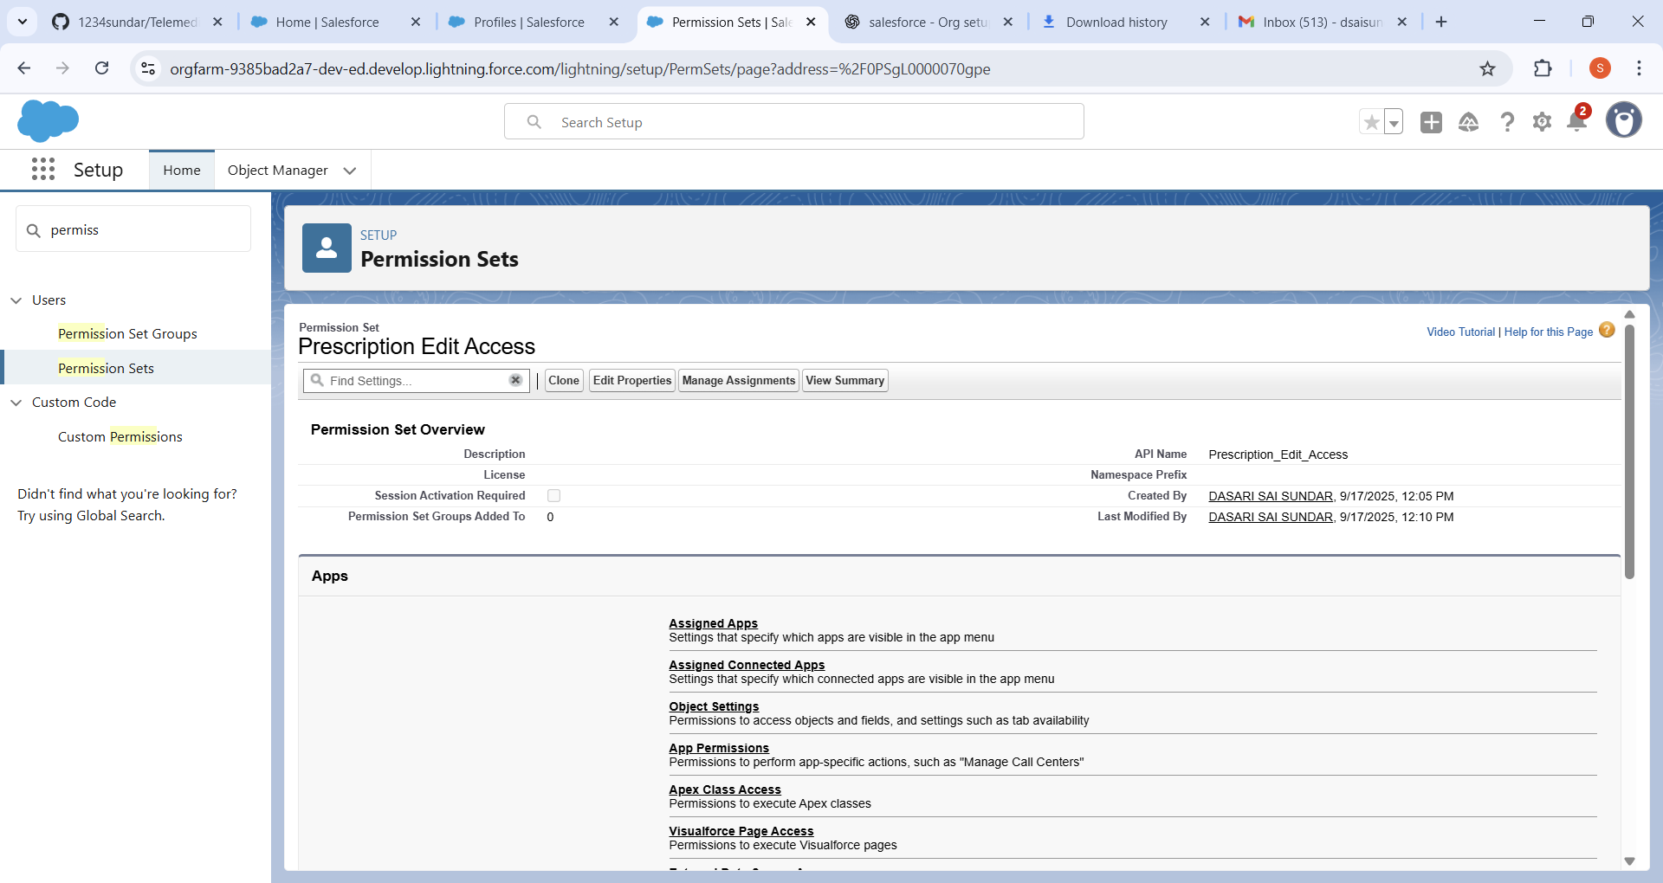

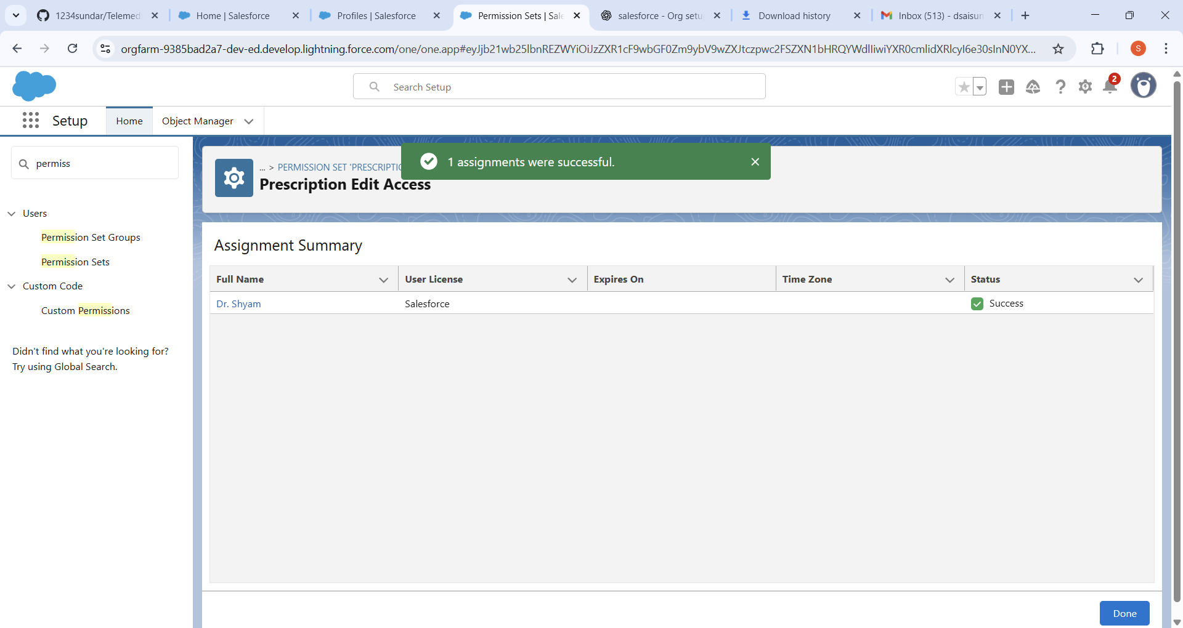

**Permission Sets** were created to provide extra access where required. For example, a permission set was created to allow doctors to access Reports and Dashboards without modifying their base profile. Patients were not assigned any permission sets as their access was limited by design. This approach ensured flexibility in managing exceptions while keeping profiles simple and secure.

**9. Organization-Wide Defaults (OWD):**



**Organization-Wide Defaults (OWD)** were configured to secure sensitive healthcare data. Patient__c was set to **Private**, meaning patients could only view their own records. TeleAppointment__c and Prescription__c were also set to **Private**, ensuring only the assigned doctor and patient could access them. Doctor__c was set to **Public Read Only**, so that doctor details such as names and availability were visible to all users. These settings established the baseline data security for the project.

**10. Sharing Rules:**

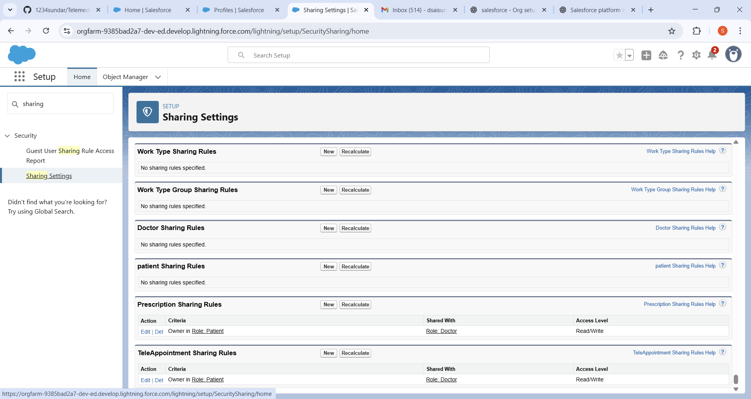

**Sharing Rules** were created to grant exceptions to OWD restrictions. TeleAppointment__c was shared with the Doctor role with **Read/Write access**. Prescription__c was also shared with the Doctor role with **Read/Write access**. These rules ensured that doctors had full access to appointments and prescriptions assigned to them while keeping patient data secure from unauthorized users.

**11. Login Access Policies**

**Login Hours** were configured for different users. Doctors were restricted to log in only between **9 AM – 8 PM**, matching their business hours. Patients were allowed 24×7 login access to book appointments at any time. **Two-Factor Authentication (2FA)** was enabled for all users to increase data security. These policies provided secure access management while supporting flexibility for patient bookings.

**12. Deployment Basics:**

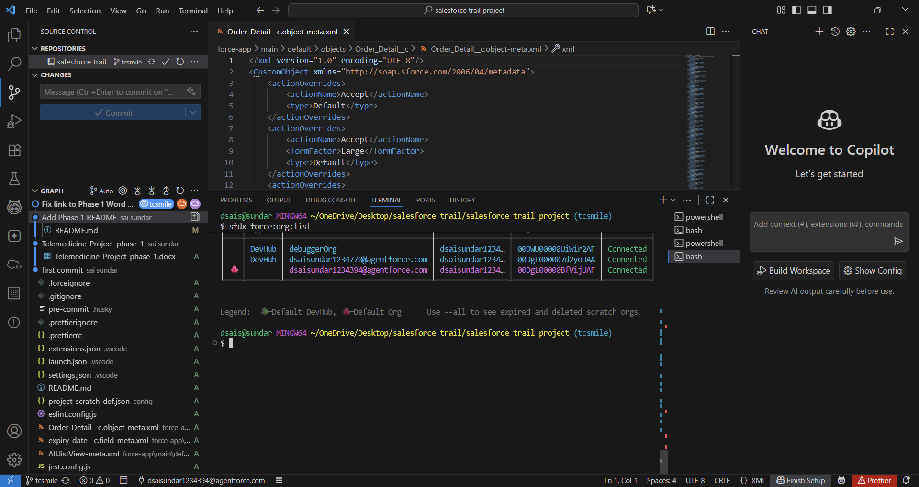

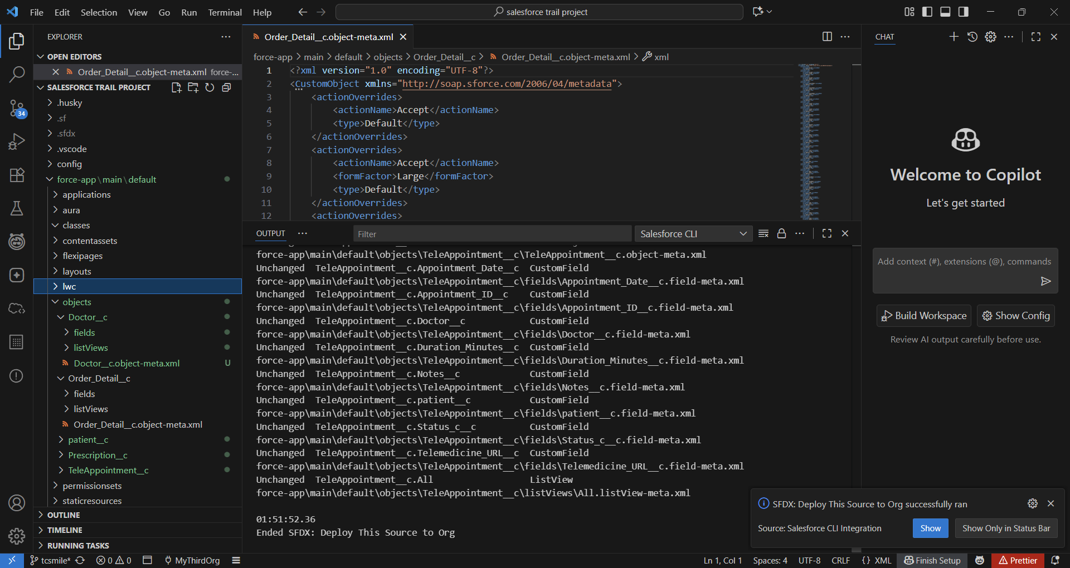

* **Patient__c** – Custom object deployed through VS Code (SFDX) to store patient details, OWD set to Private.
* **Doctor__c** – Custom object deployed through VS Code (SFDX) to store doctor details, OWD set to Public Read Only.
* **TeleAppointment__c** – Custom object deployed through VS Code (SFDX) to manage appointment bookings, OWD set to Private.
* **Prescription__c** – Custom object deployed through VS Code (SFDX) to manage prescriptions, OWD set to Private.

Deployment methods were finalized. **Change Sets** were configured for point-and-click deployments between Sandbox and Developer Org. In addition, **Salesforce DX (SFDX) with VS Code** was set up for advanced CLI-based deployments. Both methods were tested to confirm that metadata, objects, and configuration changes could be moved successfully. This completed the setup of a secure, structured deployment process for the Telemedicine project.